**EXPERIMENT-6 ZOHO**

STUDENTS ATTENDANCE SYSTEM

STEP-1 : GO to ZOHO Creator and build the app for Car Reservation

System

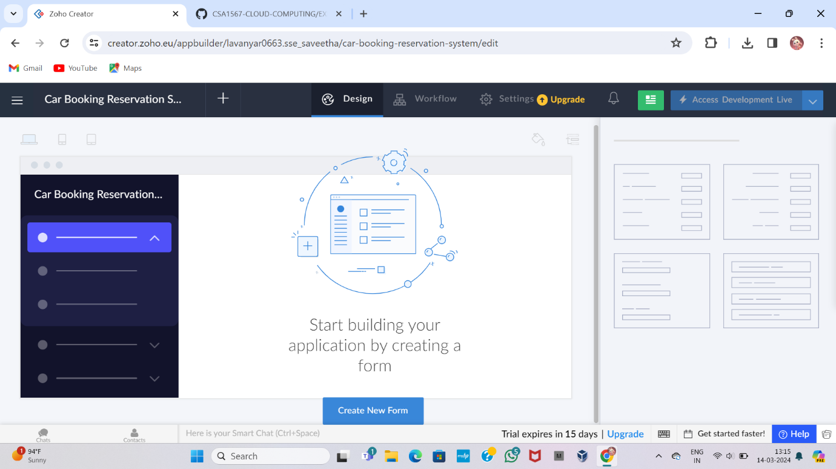

STEP-2 : Click the add new icon displayed at the top of the Design

Page

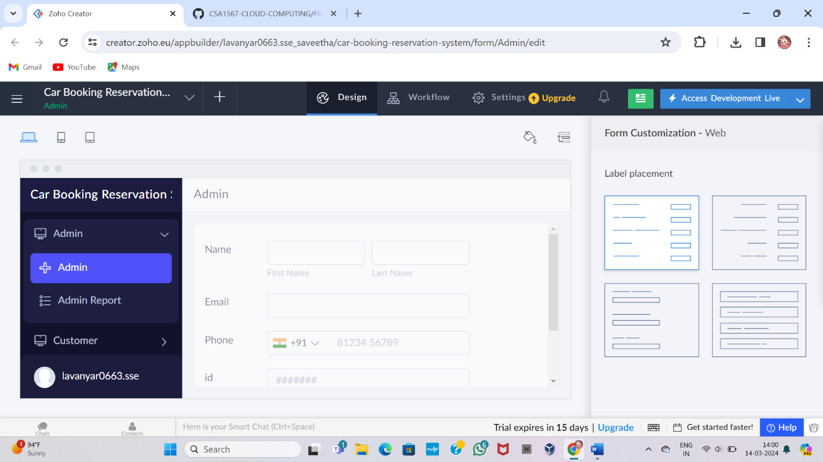

STEP-3 : Select blank and enter a name of the form, then create new form

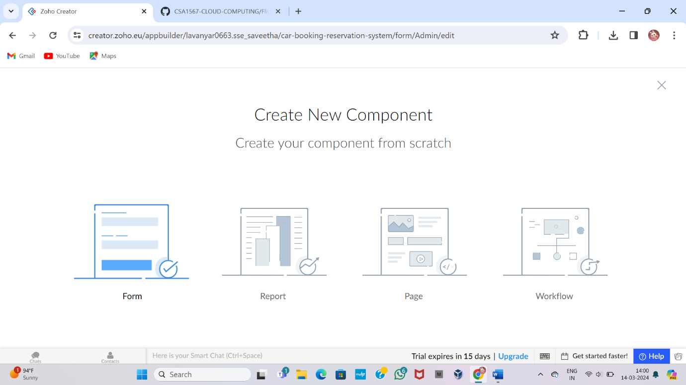

STEP-4 : It will be created to the newly created form’s builder

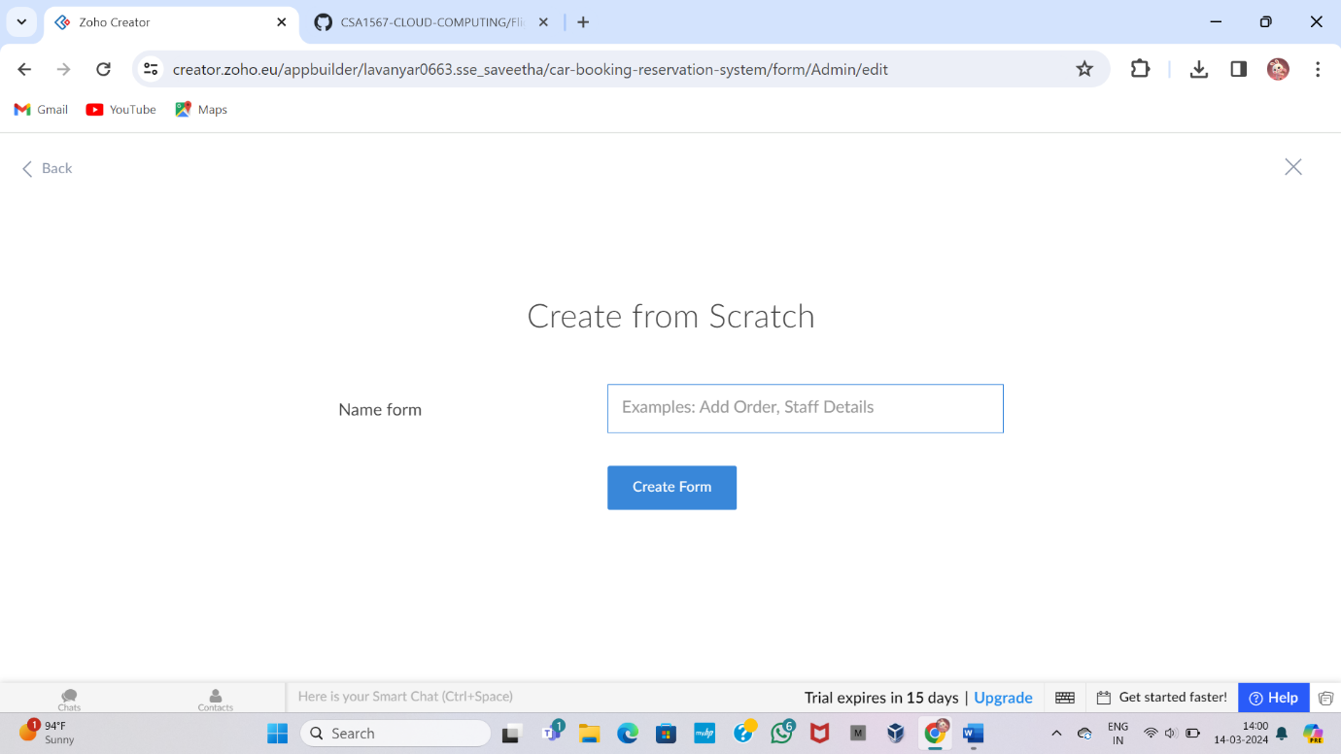

STEP-5 : Create a Teachers Form and Enter the Details

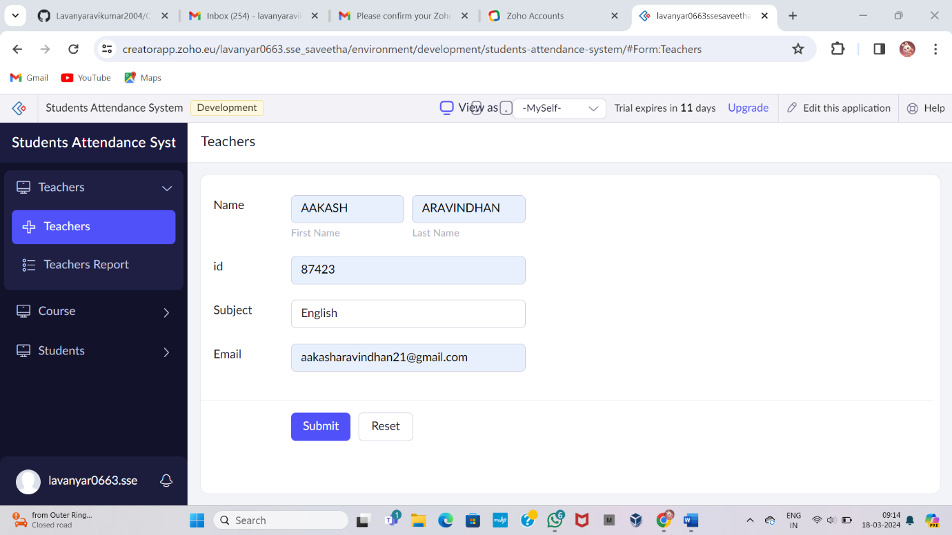

STEP-6 : Addon with that create a Course form and again fill those details

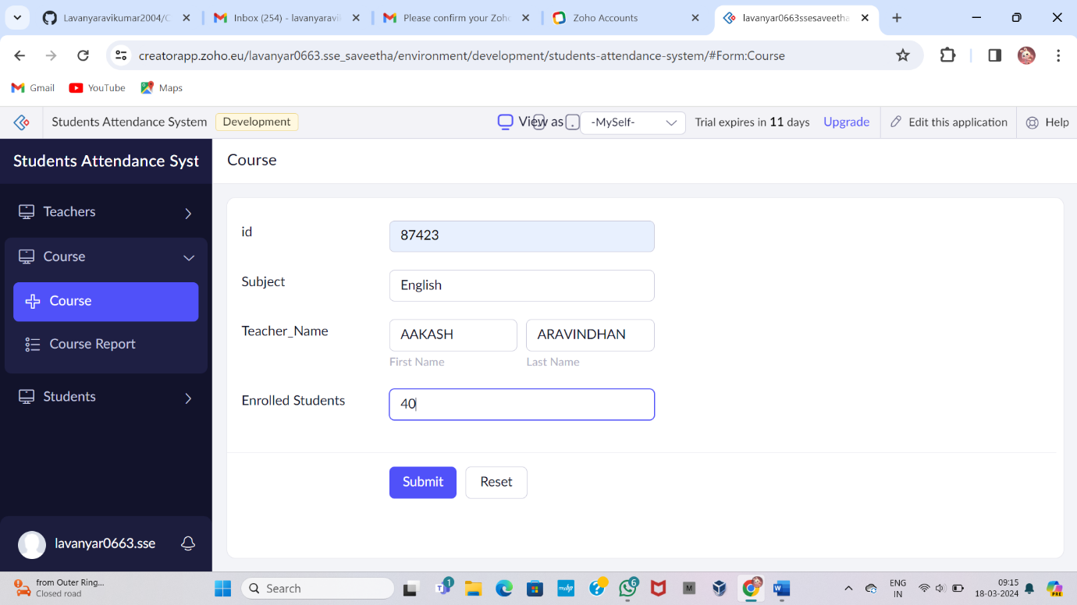

STEP-7 : Additionally, type the Students form and fill the details

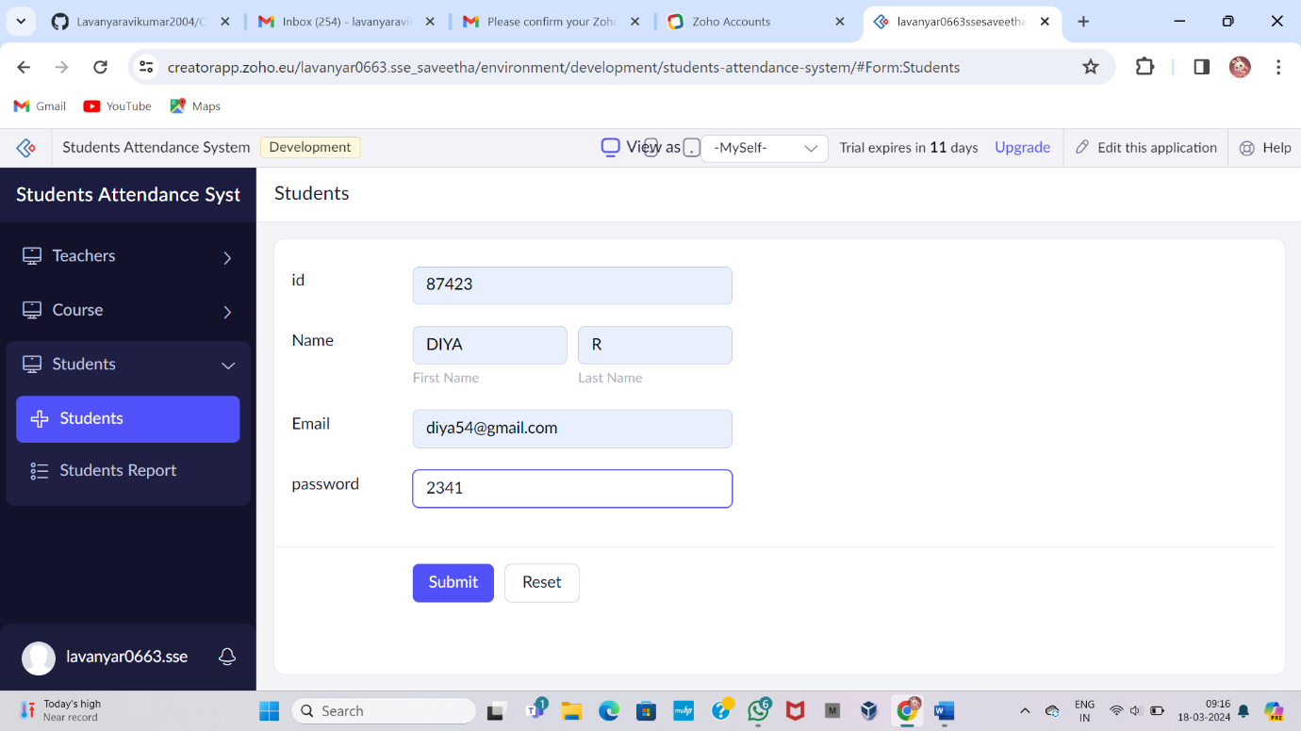

STEP-8 : Display the Teachers Form details

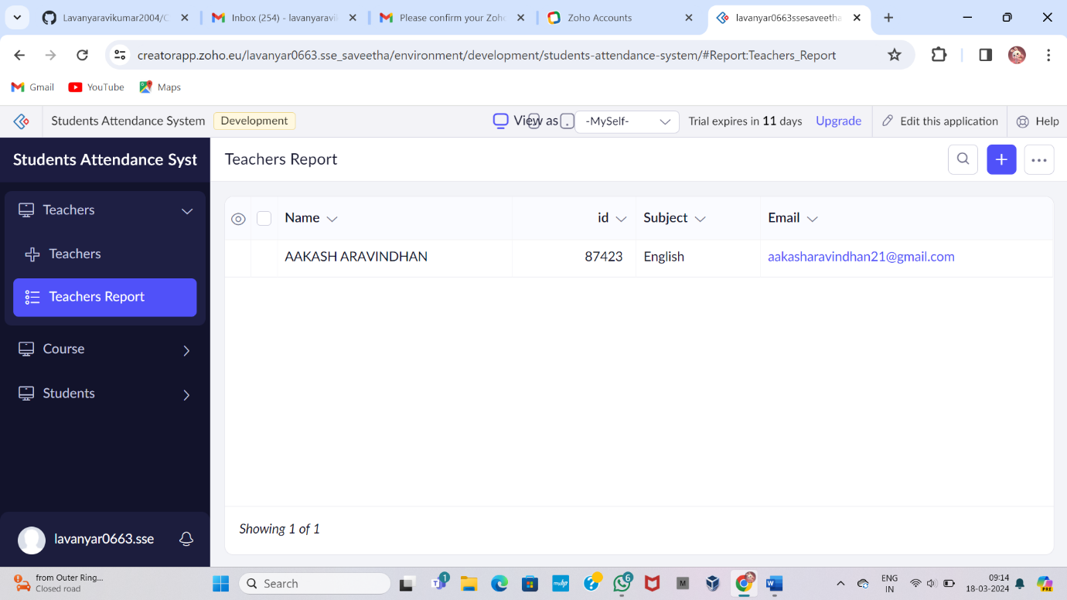

STEP-9 : Display the Course form details

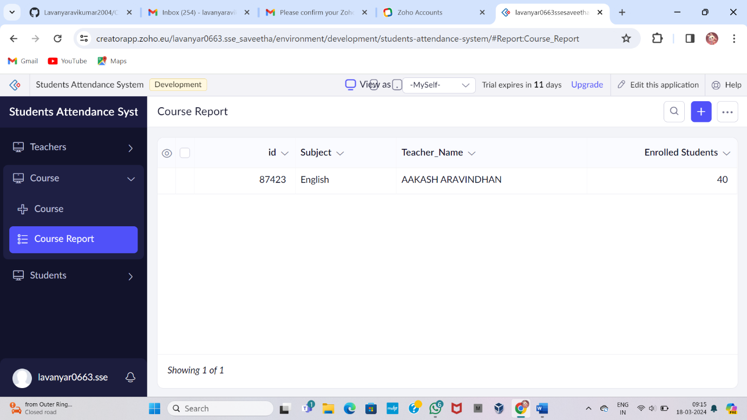

STEP-10 : Display the Students form details

